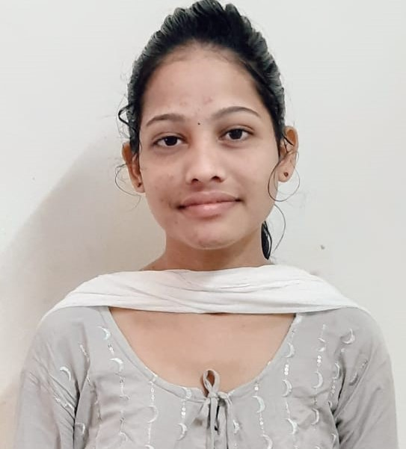

**SRUJANA**

**DOKULA**

**CAREER OBJECTIVE**

# My Contact

 srujanadokula18@gmail.com

 +919491179484

 Teacher’s colony/s.s real estates area,Paarvathipuram,parvathipuram manyam district,Andhra Pradesh

# PERSONAL SKILLS

Good communication skills Ability to work with team Dedication and Hardwork

# SOFTWARE SKILLS

C.

java python Html

TO get a good job and to gain knowledge & enhance my skills while working in a professional environment and ultimately benefit the organization and society by using best of it.

**EDUCATIONAL QUALIFICATION**

## B-Tech

MIRACLE EDUCATIONAL SOCIETY GROUP OF INSTITUTIONS*– Present*

## INTER

R.K JUNIOR COLLEGE PARVATHIPURAM 2018-2020

Percentage : 88%

**ssc**

SRI KRISHNA SCHOOL, PARVATHIPURAM

*2017-2018*

CGPA – 9.7

# Achievements

Completed Python Workshop with APSSDC Certificate for completing Bootcamp on web development

Received NPTEL certification in Internet of things

# DECLARATION

All the above furnished information is true on best of my knowledge.